Quick Guide to LTS Coats 1.4

LTS Coats 1.4 is a quasi-steady state point mass lap time simulation. In a nutshell, this program takes in a handful of parameters about a race car and simulates that race car driving around a track in order to perform lap time based sensitivity analysis. This program, having been developed specifically for Formula SAE, simulates all of the dynamic events that an FSAE car competes in. This allows for point based sensitivity analysis. A few of the current capabilities are listed below.

- Dynamic event point sensitivity analysis
- Laptime sensitivity analysis
- Endurance fuel usage calculation

This program, as with all simulation, makes a mountain of assumptions both known and unknown. Here are some of known assumptions that are being made.

- Tires are always at ideal temperature, pressure, and camber
- All yaw dynamics are ignored
- The car remains at a constant speed through a corner
- All transient effects are ignored
- The car is always at the limit of grip
- The cornering model assumes that the car is at the limit of all four tires individually, not the actual lateral limit of the car.

It is critical to keep the assumptions in mind when looking at parameter sensitivities as changing some parameters will not provide accurate results.

HOW THE PROGRAM WORKS:
This program simulates a lap using quasi-steady state point mass assumptions. Using the tire model, car parameters, and the engine model a non-linear vehicle model is generated. The vehicle model is the used to simulate the car running a lap of the given track, which is broken up into a list of corners and straights. In the corners the car is kept at a constant speed. In the straights the car is accelerated forwards (driving) and then backwards (braking). Where the two velocity curves cross is used as the braking point. The velocity vectors generated during the events are then stitched together to make a full lap. Simulating the other dynamic events is pretty straight forward from there. The skidpad and accel sims use the same vehicle model. Endurance is simulated by multiplying the single lap time by the number of laps needed to complete an endurance. Fuel usage calculation is performed by using the engine model and the velocity output vector from the lap.

HOW TO USE THE PROGRAM:
The program is run through a TUI (LTS_TUI.m) that sets up, simulates, and processes the data from all of the dynamic events. This script calls all other programs that the simulation uses.

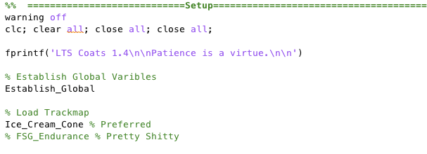
This sets up the program and loads the track map. Currently, there are only two tracks available. An ice cream cone track shown below and the endurance course from FSG. It is recommended to use the ice cream cone track as it provides a good representation of an FSAE track and it is simple enough to run quickly.
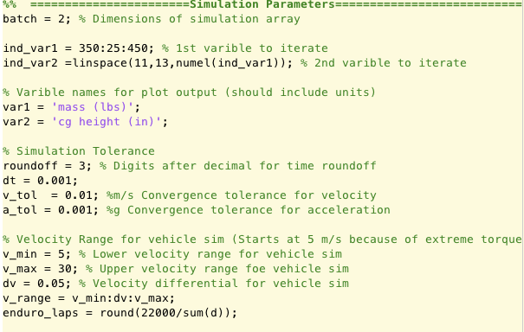
This section establishes the parameters for the simulation sweep. The variable “batch” are the dimensions of the simulation array. Simply put, if batch is set to 0, a single car setup is simulated. If batch is set to 1, a single parameter sweep is performed using ind_var1 as the iterated variable. If batch is set to 2 a double parameter sweep is performed.
Simulation tolerances are defaulted to values that were found to provide a good balance of speed and accuracy. That being said, it is encouraged to play with these values to find a balance that the user prefers. Velocity ranges and should be adjusted as needed for the vehicle model to be useful as the simulation won’t exceed the velocity range.

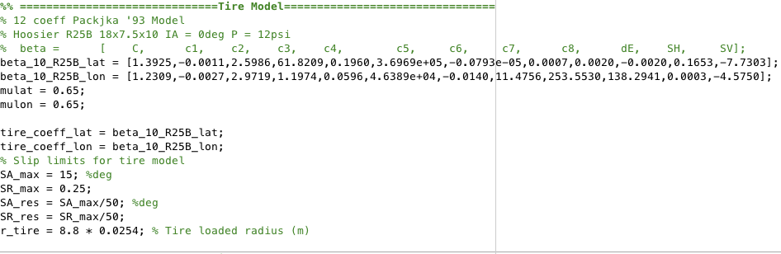

Currently the only tire model that is available is the 12 coefficient Pacejka ’93 model for the Hoosier 18x7.5-10 R25B. If another tire using the same equations is desired, simply change the coefficients. If different modelling equations are used (ex. Magic Formula 5.2) the functions that are called in Vehicle_sim_nlin.m need to be adjusted for the new equations. Slip limits for the tire model are to be treated just like the simulation tolerances and velocity ranges, adjust as needed and the larger the resolution the slower the code will run.

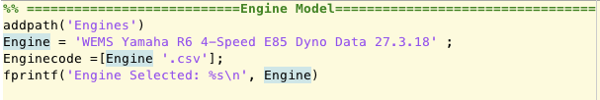

The engine model is loaded from a .csv file containing engine speed, power, torque, fuel flow, gearing, and shift points. These values can either theoretical or empirical. Theoretical values should be scaled.

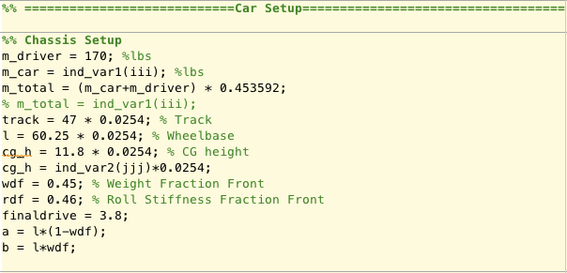
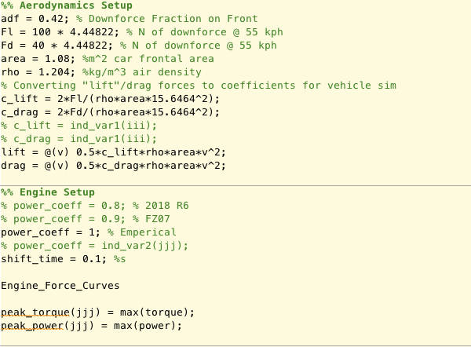

This section of the TUI is where you change the car parameters that are simulated. It is important to note that a parameter being iterated needs to be changed in BOTH simulation parameters AND the car setup sections of the code. Otherwise, the desired parameters will not be correctly simulated.
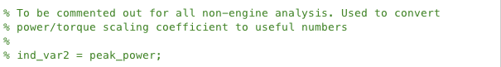
Please note that in order for the output plots to show power in actual values and not a scaling coefficient this line should be uncommented.

Output plots are controlled by the script Plot_Results.m. Simply comment or uncomment the desired plot outputs. To add more output plots, look through either Post_Processing.m or Point_Calculation.m and determine the variable names and add the necessary syntax to plot those variables.

Those are the basics of how to use LTS Coats 1.4. So, go start playing with parameters and learn what makes the car better or worse.

